**PreSchool Mobile Application**

The Preschool application has many functions available to the user. All functions were fully reliable with all working on multiple test conducting before proceeding. Functions available were all tailored to user (kids aged 2-3) requirements with an app theme that appealed to both gender of kids. A full list of functions and styling are stated below,

Random Number Generator- This function allows random numbers to come out clearly on the home screen for user to calculate the sum. The sum will print on light blue cloud with a thick black font, so that it stands out for the user to see.

Number buttons- These are buttons for the user to press when answering the sum. They are printed out in the same colour as the ‘Random question’. Keeping the consistency of the application design, so that the kid doesn’t get confused. When the user clicks on the number it becomes highlighted so that the kid can see what number they are picking. “it is still important to maintain a visual hierarchy and emphasize elements that are interactive. You can achieve this by making clickable or tappable elements bigger, adding subtle drop shadows” (Pablo ,2008)

Background image/Theme- Following ‘Jacob Nielsen’ aesthetic and design *“Dialogues should not contain information which is irrelevant or rarely needed”*(Jacob Nielsen 1995). *The* home page theme was a summers day in nature with butterflies and flowers. This theme was chosen due to the vivid selection of colours and shapes. “*The background illustrations are generally very colourful in such layouts, which create an immersive and exploratory experience for children* ” (Naranjo-Bock, 2011). The background image has a range of natural colours. *“Blue turned out to be most popular across the board, followed by green for men and purple for women.”* (Wolchover,2012) As you can see that most popular colours by our species are all included in the application making it very appealing to the users.

Flower drag able image- These images were turned into draggable images so that the user can freely move them around the screen, so it shows the perception of counting up so that the sum is answered correctly. These images follow the background theme of a summers day on a field with vibrant purple flowers for the user to interact with.

Bad screen- when the wrong answer is inserted into the sum, a thumbs down emoticon appears at the top of the page for 2 seconds. This indicates to the user that the answer inserted is incorrect. The thumbs down emoticon was chosen to keep consistency of the theme chosen. This was beneficial to the user as the kids could get the meaning of different images confused.

Congratulations page- When the answer is inputted correctly the second page is loaded up. This page includes the same background of the home page, keeping consistency. But instead has confetti and a thumbs up emoticon to represent celebration due to the correct answer be entered. The colours on this page are also bright and vivid.

Animations- The animations used in this application were kept simple yet affective. As they include movement of the flowers side to side minimally, the ‘congratulations’ emoticon jumping and also a finger tapping on the screen to show an instruction to the user. This emphesis ‘Jakub Nielsens’3rd usability heuristic stating *“The system should always keep users informed about what is going on”.* (Jakub Nielsen's.1995) These animations were used mainly to show instructions for the user to interact with the application and also for a graphical visual experience. *“in applications for children, audio and animation cues generally accompany such visual emphasis, prompting users to action”*( Naranjo-Bock, 2011).

Sounds- As studied by the (Department of education(USA),2003). From birth of a kid to the age of 3, as they progress they tend to *“Make sounds that imitate the tones and rhythms”.* The application also features a range of sound effects and background music to increase the user experience. By adding in music background it increases popularity and appeals to kids to play the application.

**Future work**

If given another opportunity to develop this application, I would change it minimally but instead add to it. The first extra feature that would be added would be a choice of themes. Themes can be related to a single gender or even a kids theme such as a sport. By adding this feature, it will make every users experience unique. This will increase popularity across the market. Another factor that I would change is the shade of the colours chosen. For them to be brighter and thicker. Rather than the colours been used now being dull. This would appeal more to the target audience.

**Conclusion**

All in all, the application made met function requirements for the target audience. It also showed a understanding of themes and colours chosen to appeal to the users. A simple choice of animation was used to target kids into remembering the application for further use. If another chance was given to improve my application, I would do so in ways discussed above. By implementing these extra features, it will attract many more kids as it could possibly be talked about in kids environments such as school playgrounds.

Appendices

Trello

Trello was used in a way to keep track of my development throughout my project. This followed an agile web development methodology. This print screens show the development of the project shown on the activity on the right side of the pages.

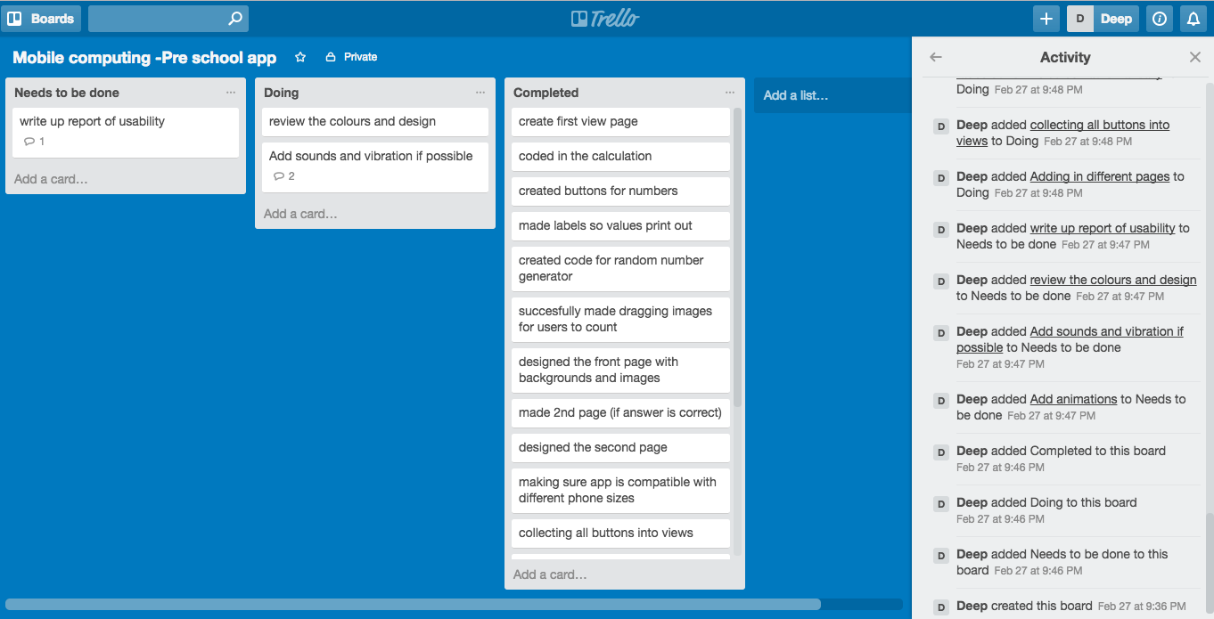

Figure

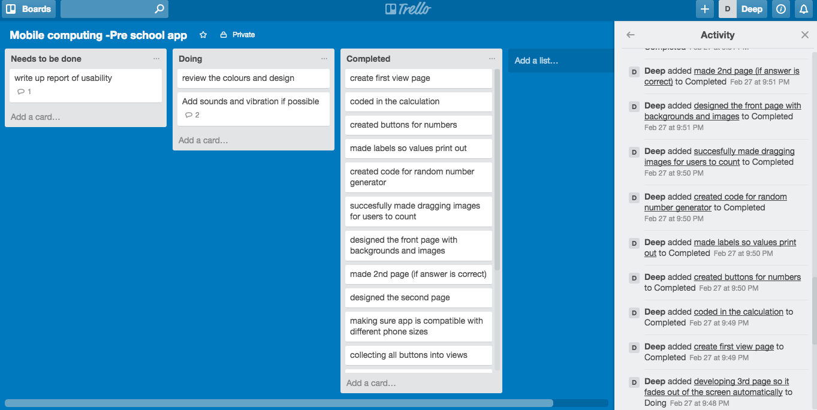

Figure

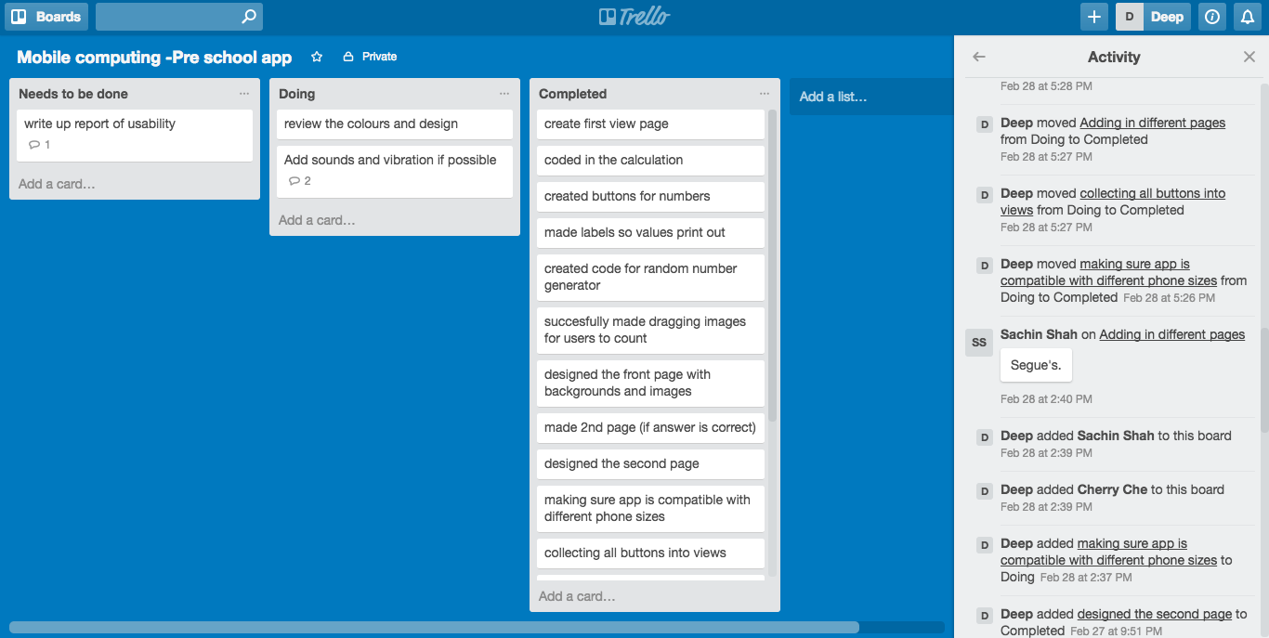

Figure

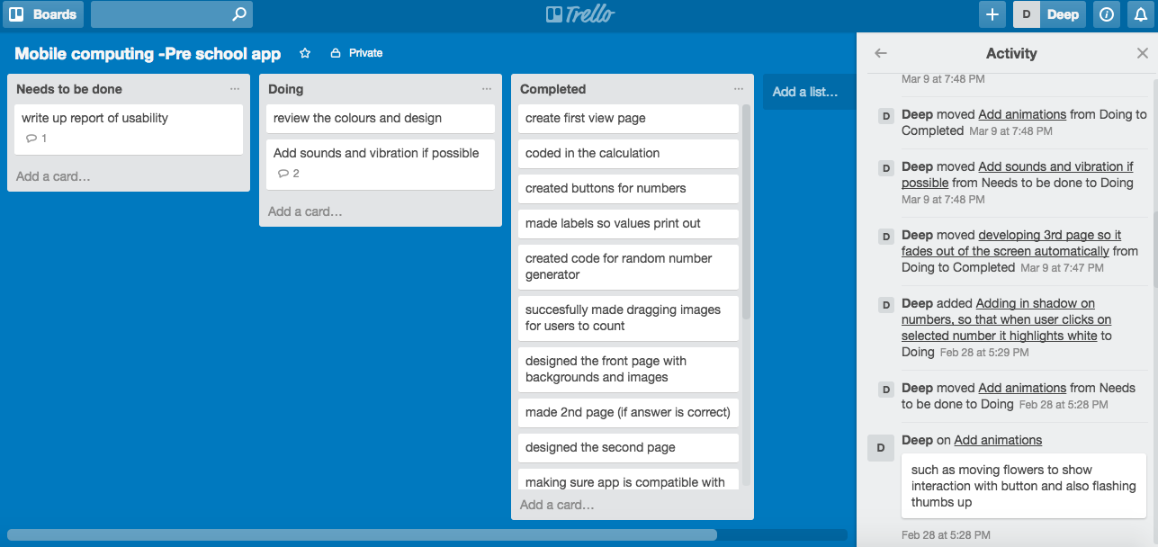

Figure

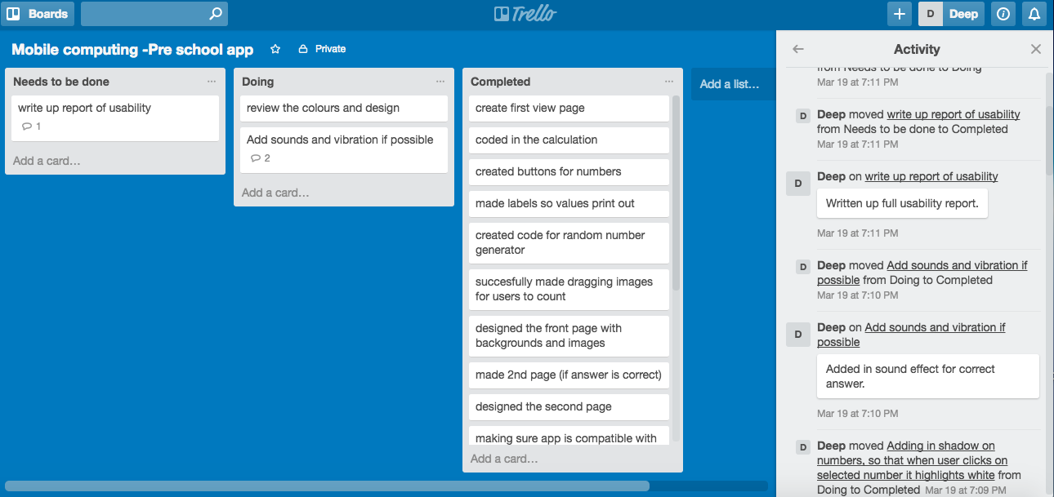

Figure

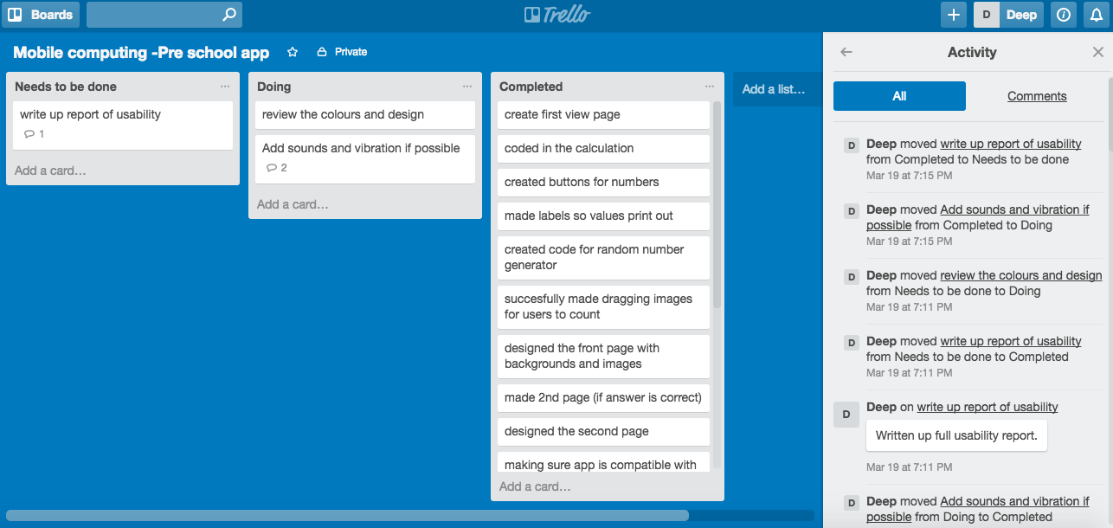

Figure

**Github**

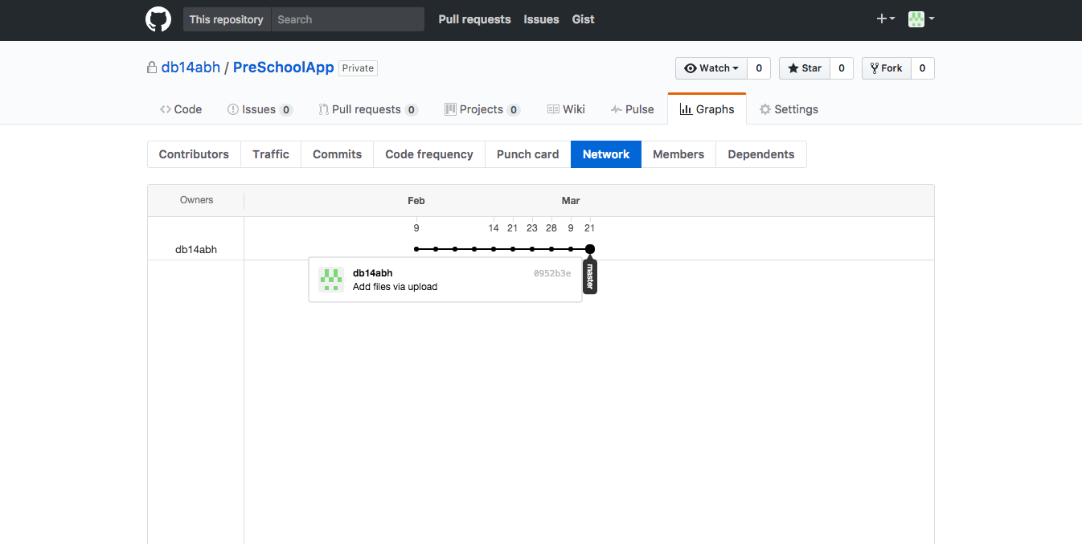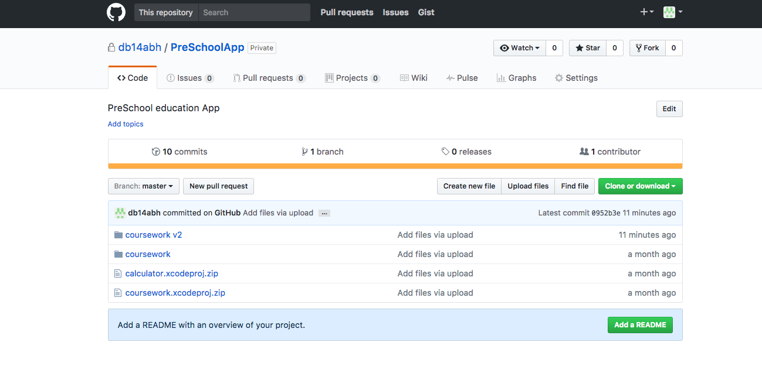

Figure

Figure

**References**

UXmatters :: Insights and inspiration for the user experience community. 2017. UXmatters :: Insights and inspiration for the user experience community. [ONLINE] Available at: [http://www.uxmatters.com](http://www.uxmatters.com/). [Accessed 21 March 2017].

Live Science. 2017. *Humanity's Favorite Colors | What's Your Favorite Color?*. [ONLINE] Available at: <http://www.livescience.com/34105-favorite-colors.html>. [Accessed 21 March 2017].

Techopedia.com. 2017. *What is a Mobile Application? - Definition from Techopedia*. [ONLINE] Available at: <https://www.techopedia.com/definition/2953/mobile-application-mobile-app>. [Accessed 21 March 2017].

Hourcade, Juan Pablo. “[Interaction Design and Children](http://www.cs.uiowa.edu/~hourcade/publications.html).”[http://www.uxmatters.com/images/new-window-arrow.gif](http://www.cs.uiowa.edu/~hourcade/publications.html) Foundations and Trends in Human-Computer Interaction, Vol. 1, No. 4, 2008. Retrieved September 19, 2011.

10 Heuristics for User Interface Design: Article by Jakob Nielsen. 2017. 10 Heuristics for User Interface Design: Article by Jakob Nielsen. [ONLINE] Available at: https://www.nngroup.com/articles/ten-usability-heuristics/. [Accessed 21 March 2017].